Dichotomous Key Vocabulary
Words | Definitions
Symmetry: Radial | Radiates from a central point (think geometry: a radius)
Symmetry: Segmented | Divided into parts
Symmetry: Asymmetrical | Not identical on both sides: Rihanna’s hair is asymmetrical.
Symmetry: Bilateral | Two, identical sides
SYMMETRY
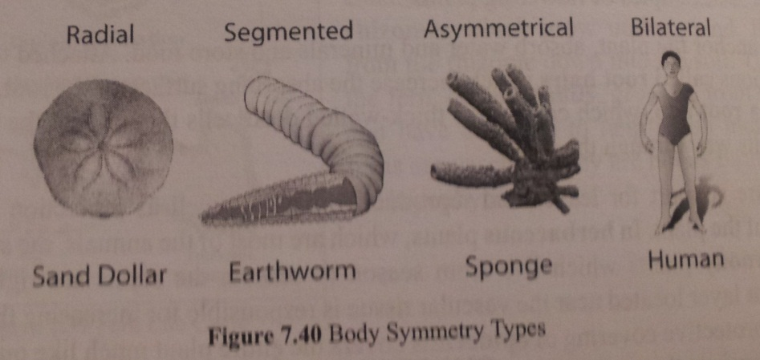

exoskeleton | An external, hard covering (think shell)
Nervous system | If it has a head, it has a nervous system
Closed circulatory system | Blood contained within blood vessels
Open circulatory system | Blood flows freely in cavity
hermaphrodite | An individual that has reproductive organs from both sexes

