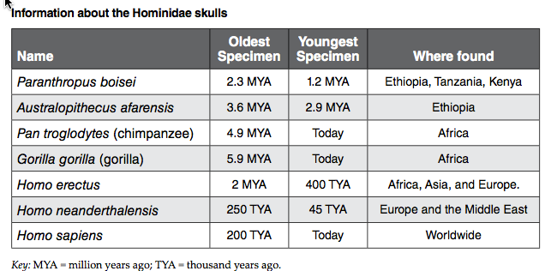
Family Hominidae Skull Characteristics

Linnaean Classification
Domain | Eukarya
Kingdom | Animalia
Phylum | Chordata
Class | Vertebrata
Order | Primates
Family | Hominidae
Genus | See chart above
Species | See chart above
Species | Size of Braincase  FB SS |  | Sagittal Crest  (Y/N) | Mastoid Process Flat or Protruding | Nasal Bones Arched or Flat | Length Mandible (cm) | Width of 4 Incisors (cm) | Protruding Canine (Y/N) | Canine Diastema (Y/N) | Combined Premolar and Molar (cm)
Paranthropus boisei | 13.2 | 11.0 | Yes | Protruding | Flat | 7.0 | 1.1 | No | No | 3.9
Australopithecus afarensis | 11.0 | 10.1 | Yes | Protruding | Flat | 5.8 | 1.4 | No | No | 2.7
Pan troglodytes | 9.9 | 10.2 | Yes | Flat | Flat | 6.2 | 1.4 | Yes | Yes | 2.6
Gorilla gorilla | 11.0 | 10.4 | Yes | Flat | Flat | 7.4 | 1.4 | Yes | Yes | 3.7
Homo erectus | 14.9 | 12.8 | No | Protruding | Yes | 5.0 | 1.1 | No | No | 2.5
Homo neanderthalensis | 16.8 | 14.9 | No | Protruding | Arched | 5.8 | 1.4 | No | No | 2.2
Homo sapiens | 16.6 | 15.0 | No | Protruding | Arched | 4.4 | 1.1 | No | No | 2.0

How Measurements Were Made

Size of Braincase (Use string & ruler)
- Front to Back: Brow ridge to Foramen magnum (hole for spinal cord)
- Side to Side: External auditory meatus (earhole) to External auditory meatus (earhole)
* Be sure to only measure brain case not extra bone

Length of Mandible:
- Base of teeth linearly to edge of mandible

Width of 4 Incisors
- Edge of first incisor tooth to edge of fourth incisor tooth

Combined Premolar and Molar Length
- Edge of first premolar to edge of back molar

